**PRACTICAL NO.3**

**Programming Activities and fragments**

**Activity Life Cycle, Activity methods, Multiple Activities, Life Cycle of fragments and multiple fragments.**

**Code:**

**activity_main.xml**

<?xml version="1.0" encoding="utf-8"?>  
<androidx.constraintlayout.widget.ConstraintLayout xmlns:android="http://schemas.android.com/apk/res/android"  
 xmlns:app="http://schemas.android.com/apk/res-auto"  
 xmlns:tools="http://schemas.android.com/tools"  
 android:layout_width="match_parent"  
 android:layout_height="match_parent"  
 tools:context=".MainActivity"  
 >  
  
 <Button  
 android:id="@+id/button"  
 android:layout_width="wrap_content"  
 android:layout_height="wrap_content"  
 android:text="Next Page"  
 app:layout_constraintBottom_toBottomOf="parent"  
 app:layout_constraintEnd_toEndOf="parent"  
 app:layout_constraintStart_toStartOf="parent"  
 app:layout_constraintTop_toTopOf="parent"  
 app:layout_constraintVertical_bias="0.042" />  
  
 <androidx.fragment.app.FragmentContainerView  
 android:id="@+id/fragmentContainerView"  
 android:name="com.example.demo.FirstFragment"  
 android:layout_width="300dp"  
 android:layout_height="400dp"  
 app:layout_constraintBottom_toBottomOf="parent"  
 app:layout_constraintEnd_toEndOf="parent"  
 app:layout_constraintStart_toStartOf="parent"  
 app:layout_constraintTop_toTopOf="parent" />  
  
 <Button  
 android:id="@+id/button2"  
 android:layout_width="wrap_content"  
 android:layout_height="wrap_content"  
 android:text="Change Fragment"  
 app:layout_constraintBottom_toBottomOf="parent"  
 app:layout_constraintEnd_toEndOf="parent"  
 app:layout_constraintStart_toStartOf="parent"  
 app:layout_constraintTop_toTopOf="parent"  
 app:layout_constraintVertical_bias="0.128" />  
</androidx.constraintlayout.widget.ConstraintLayout>

**MainActivity.kt**

package com.example.demo  
  
import android.content.Intent  
import android.graphics.Color  
import androidx.appcompat.app.AppCompatActivity  
import android.os.Bundle  
import android.widget.Toast  
import kotlinx.android.synthetic.main.activity_main.*  
import kotlinx.android.synthetic.main.activity_second_page.*  
  
class MainActivity : AppCompatActivity() {  
 override fun onCreate(savedInstanceState: Bundle?) {  
 super.onCreate(savedInstanceState)  
 setContentView(R.layout.activity_main)  
 Toast.makeText(this,"onCreate()",Toast.LENGTH_LONG).show()  
  
 button.setOnClickListener {  
 var nextPage=Intent(this,secondPage::class.java)  
 startActivity(nextPage)  
 }  
  
 var flag=0  
 var fm=supportFragmentManager  
 button2.setOnClickListener {  
 if(flag==0){  
 fm.beginTransaction().replace(R.id.fragmentContainerView,SecondFragment()).commit()  
 flag=1  
 }  
 else{  
 fm.beginTransaction().replace(R.id.fragmentContainerView,FirstFragment()).commit()  
 flag=0  
 }  
 }  
 }  
  
 override fun onStart() {  
 super.onStart()  
 Toast.makeText(this,"onStart()",Toast.LENGTH_LONG).show()  
 }  
  
 override fun onPause() {  
 super.onPause()  
 Toast.makeText(this,"onPause()",Toast.LENGTH_LONG).show()  
 }  
  
 override fun onResume() {  
 super.onResume()  
 Toast.makeText(this,"onResume()",Toast.LENGTH_LONG).show()  
 }  
  
 override fun onRestart() {  
 super.onRestart()  
 Toast.makeText(this,"onRestart()",Toast.LENGTH_LONG).show()  
 }  
  
 override fun onStop() {  
 super.onStop()  
 Toast.makeText(this,"onStop()",Toast.LENGTH_LONG).show()  
 }  
  
 override fun onDestroy() {  
 super.onDestroy()  
 Toast.makeText(this,"onDestroy()",Toast.LENGTH_LONG).show()  
 }  
}

**activity_second_page.xml**

<?xml version="1.0" encoding="utf-8"?>  
<androidx.constraintlayout.widget.ConstraintLayout xmlns:android="http://schemas.android.com/apk/res/android"  
 xmlns:app="http://schemas.android.com/apk/res-auto"  
 xmlns:tools="http://schemas.android.com/tools"  
 android:layout_width="match_parent"  
 android:layout_height="match_parent"  
 tools:context=".secondPage"  
 android:id="@+id/bgid"  
 >  
  
 <TextView  
 android:id="@+id/textView"  
 android:layout_width="wrap_content"  
 android:layout_height="wrap_content"  
 android:text="Hello it is second page"  
 app:layout_constraintBottom_toBottomOf="parent"  
 app:layout_constraintEnd_toEndOf="parent"  
 app:layout_constraintHorizontal_bias="0.498"  
 app:layout_constraintStart_toStartOf="parent"  
 app:layout_constraintTop_toTopOf="parent"  
 app:layout_constraintVertical_bias="0.259" />  
  
 <Button  
 android:id="@+id/click"  
 android:layout_width="wrap_content"  
 android:layout_height="wrap_content"  
 android:text="Click"  
 app:layout_constraintBottom_toBottomOf="parent"  
 app:layout_constraintEnd_toEndOf="parent"  
 app:layout_constraintHorizontal_bias="0.498"  
 app:layout_constraintStart_toStartOf="parent"  
 app:layout_constraintTop_toTopOf="parent"  
 app:layout_constraintVertical_bias="0.351" />  
  
 <TextView  
 android:id="@+id/textView2"  
 android:layout_width="wrap_content"  
 android:layout_height="wrap_content"  
 app:layout_constraintBottom_toBottomOf="parent"  
 app:layout_constraintEnd_toEndOf="parent"  
 app:layout_constraintHorizontal_bias="0.498"  
 app:layout_constraintStart_toStartOf="parent"  
 app:layout_constraintTop_toTopOf="parent"  
 app:layout_constraintVertical_bias="0.424" />  
</androidx.constraintlayout.widget.ConstraintLayout>

**secondPage.kt**

package com.example.demo  
  
import android.graphics.Color  
import androidx.appcompat.app.AppCompatActivity  
import android.os.Bundle  
import androidx.constraintlayout.widget.ConstraintLayout  
import kotlinx.android.synthetic.main.activity_second_page.*  
  
class secondPage : AppCompatActivity() {  
 override fun onCreate(savedInstanceState: Bundle?) {  
 super.onCreate(savedInstanceState)  
 setContentView(R.layout.activity_second_page)  
 click.setOnClickListener {  
 textView2.text="Hello Student from SRM College"  
 }  
 }  
}

**fragment_first.xml**

<?xml version="1.0" encoding="utf-8"?>  
<FrameLayout xmlns:android="http://schemas.android.com/apk/res/android"  
 xmlns:tools="http://schemas.android.com/tools"  
 android:layout_width="match_parent"  
 android:layout_height="match_parent"  
 tools:context=".FirstFragment"  
 >  
 <!-- TODO: Update blank fragment layout -->  
 <TextView  
 android:layout_width="300dp"  
 android:layout_height="300dp"  
 android:layout_gravity="center"  
 android:gravity="center"  
 android:text="This is First Fragment"  
 android:textSize="20dp" />  
  
</FrameLayout>

**FirstFragment.kt**

package com.example.demo  
  
import android.content.Context  
import android.os.Bundle  
import androidx.fragment.app.Fragment  
import android.view.LayoutInflater  
import android.view.View  
import android.view.ViewGroup  
import android.widget.Toast  
  
class FirstFragment : Fragment() {  
 override fun onCreate(savedInstanceState: Bundle?) {  
 super.onCreate(savedInstanceState)  
 }

override fun onCreateView(  
 inflater: LayoutInflater, container: ViewGroup?,  
 savedInstanceState: Bundle?  
 ): View? {  
 // Inflate the layout for this fragment  
 var root=inflater.inflate(R.layout.fragment_first, container, false)  
 Toast.makeText(context,"This is First Fragment",Toast.LENGTH_SHORT).show()  
 return root  
 }  
  
 override fun onAttach(context: Context) {  
 super.onAttach(context)  
 Toast.makeText(context,"onAttach()",Toast.LENGTH_LONG).show()  
 }  
  
 override fun onDetach() {  
 super.onDetach()  
 Toast.makeText(context,"onDetach()",Toast.LENGTH_LONG).show()  
 }  
}

**fragment_second.xml**

<?xml version="1.0" encoding="utf-8"?>  
<androidx.constraintlayout.widget.ConstraintLayout xmlns:android="http://schemas.android.com/apk/res/android"  
 xmlns:app="http://schemas.android.com/apk/res-auto"  
 xmlns:tools="http://schemas.android.com/tools"  
 android:id="@+id/bgcol"  
 android:layout_width="300dp"  
 android:layout_height="300dp"  
 tools:context=".SecondFragment"  
 android:layout_gravity="center"  
 >  
 <!-- TODO: Update blank fragment layout -->  
 <Button  
 android:id="@+id/button3"  
 android:layout_width="wrap_content"  
 android:layout_height="wrap_content"  
  
 android:text="Button"  
 app:layout_constraintBottom_toBottomOf="parent"  
 app:layout_constraintEnd_toEndOf="parent"  
 app:layout_constraintStart_toStartOf="parent"  
 app:layout_constraintTop_toTopOf="parent" />  
  
</androidx.constraintlayout.widget.ConstraintLayout>

**SecondFragment.kt**

package com.example.demo  
  
import android.graphics.Color  
import android.os.Bundle  
import androidx.fragment.app.Fragment  
import android.view.LayoutInflater  
import android.view.View  
import android.view.ViewGroup  
import android.widget.Toast  
import kotlinx.android.synthetic.main.activity_second_page.*  
import kotlinx.android.synthetic.main.fragment_second.*  
import kotlinx.android.synthetic.main.fragment_second.view.*  
  
class SecondFragment : Fragment() {  
 override fun onCreate(savedInstanceState: Bundle?) {  
 super.onCreate(savedInstanceState)  
 }  
  
 override fun onCreateView(  
 inflater: LayoutInflater, container: ViewGroup?,  
 savedInstanceState: Bundle?  
 ): View? {  
 // Inflate the layout for this fragment  
 var root= inflater.inflate(R.layout.fragment_second, container, false)  
 var op:Int=0  
 root.button3.setOnClickListener {  
 if(op==0){  
 bgcol.setBackgroundColor(Color.BLUE)  
 op=1  
 }  
 else{  
 bgcol.setBackgroundColor(Color.RED)  
 op=0  
 }  
 }  
 Toast.makeText(context,"This is Second Fragment",Toast.LENGTH_SHORT).show()  
 return root  
 }  
}

**Output:**

**activity_main.xml & fragment_first.xml**

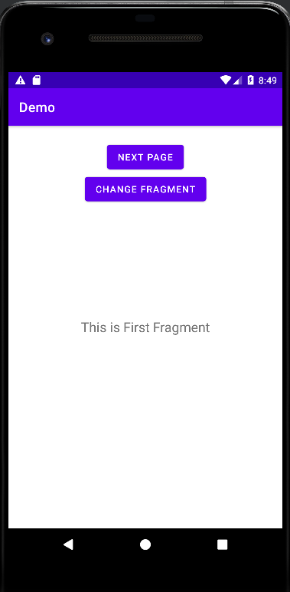 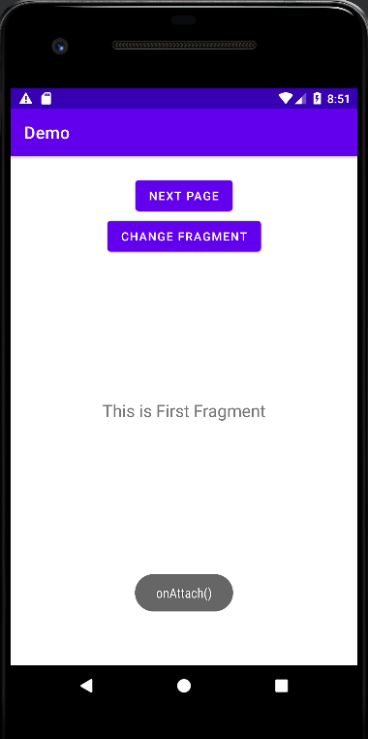

**activity_second_page.xml & fragment_second.xml**

